Mobile Apps 2024
Assignment 1

Umesh Yadav
Student no. 25327

Lyca mobile APP


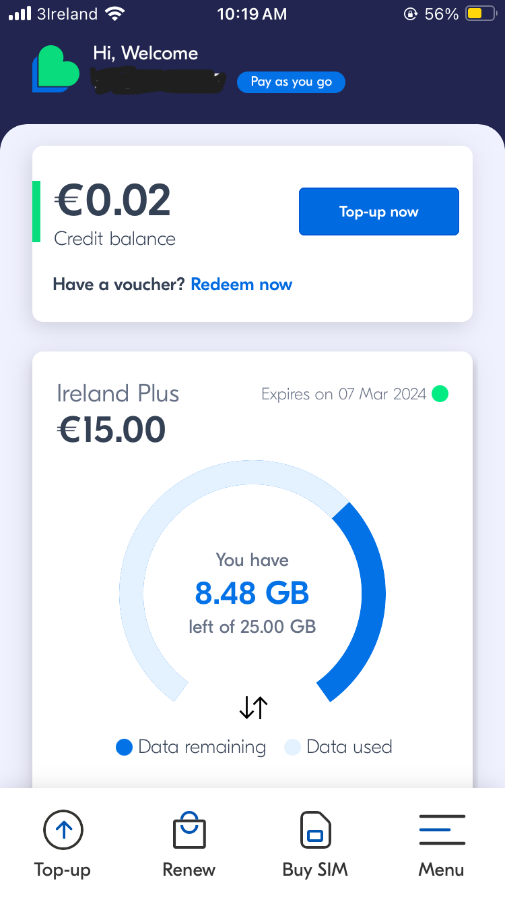 Screenshot: 1

I have chosen lyca mobile app and I selected three pages of that app. First page is home page which leads to other options, second page is of Menu where we can see many other services option according to our convenience and the last page which I have chosen is of history where it provides us option to check their history of top ups and payment.

Firstly, I’m going to explain about home page, home starting from its origin on the top there are some information which is column wise and space around which starts from network logo and in centre it shows time and end with battery logo. Then in the second column it has its top navigation bar some piece of text which is from start line till centre, in third column which is spaced in centre and have some text which is starting from right and end on the left and spaced between. In fourth column which is bigger and spaced in centre. It also has some text which starts from right and end on the left which is spaced as space around, then in second row it has an element which is spaced centre and has some text which is also spaced centre, then in the third row it has some text which is spaced evenly.
In the fifth column it has four element which is spaced around.

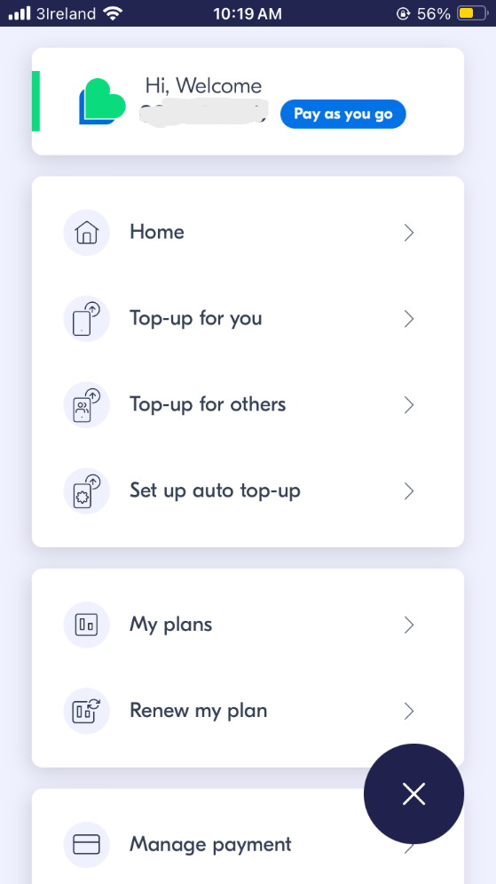screenshot: 2

the second layout is of menu bar, it has four column which are spaced centre. In the first column it has some piece of text which is spaced around. In second column we have four rows each row contains a column which starts from right and end on the left and spaced evenly. In third column we have two rows and both are spaced evenly and both has texts which starts from right and end on the left.
In the fourth column it has some rows as well as some as third column.
At the end there is a permanent element which is at the bottom left on the screen and spaced flex-end.

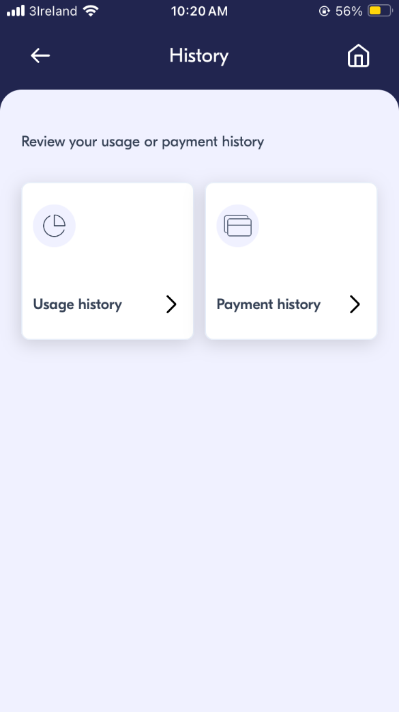Screenshot:3

History page starting from its origin on the top there are some information which is column wise and space around which starts from network logo and in centre it shows time and end with battery logo. Then in the first column it has its navigation bar on the top which is spaced evenly has element on left and right side and text in the centre. Then in the second column there is a text which is spaced flex-start. At the last there are two column one is for Top up history and second is for Payment history and which are spaced around as well as both column has two rows and in the first column both have element spaced as flex-start and in second row of both column has some piece of text which has space around and staring from text and end with an element.

